 | Title : Project Registration & Progress Review |  | FF No. 180
Department: AI&DS |  | Academic Year:2025 - 2026
Semester : V |  | Group No. : TY-B-7
Project Title: Real-time Object Detection with YOLO
Project Area: AI,ML,DL,Computer Vision,Image Processing,Edge AI/Embedded Systems
Robotics & Autonomous Systems
Group Members Details:

Sr. No. | Class & Div. | Roll No. | G.R.No. | Name of Student | Contact No. | Email ID
1 | AIDS - B | 55 | 12420024 | Arya Shah | 7385108761 | arya.shah24@vit.edu
2 | AIDS - B | 59 | 12420043 | Siony Chaudhari | 7741992669 | siony.chaudhari24@vit.edu
3 | AIDS - B | 61 | 12420054 | Shreya Anjikhane | 9028402146 | shreya.anjikhane24@vit.edu
4 | AIDS - B | 69 | 12420142 | Vaibhav Mhetre | 9763718566 | vaibhav.mhetre24@vit.edu
5 | AIDS - B | 70 | 12420150 | Aditya Dhakane | 9309298067 | aditya.dhakane24@vit.edu

Name of Internal Guide: Dr. Minal Yadavrao Barhate Contact No. & Email ID: 73877 00474 & minal.barhate@vit.edu

Project approved / Not approved

Dr. Minal Yadavrao Barhate Dr. Hrushikesh Joshi Dr. Shital Dongare
Guide Project Coordinator Head of Department

Project Synopsis:

Introduction
Object detection is an essential computer vision task where systems identify and locate multiple objects in images or videos. Traditional methods struggle with real-time performance, but YOLO (You Only Look Once) provides a deep learning approach that is both fast and accurate, making it suitable for real-world applications such as security, automation, and autonomous systems.

Problem Statement
Traditional detection methods are often too slow or inaccurate for real-time use. The challenge is to build a system that can detect multiple objects instantly and accurately in live video streams. YOLO provides a solution by combining high detection speed with strong accuracy.

Objectives
- Collect and preprocess datasets
- Train and implement a YOLO-based model for real-time detection.
- Optimize the model for speed + accuracy.
- Evaluate performance using metrics: Precision, Recall, F1-score, mAP.
- Deploy the model for real-time detection via webcam/video streams.

Methodology :
- Data Collection & Preprocessing – using standard or custom datasets with annotation tools like LabelImg.
- Model Development – implement YOLOv5/YOLOv8 using PyTorch.
- Training & Testing – run training on GPU-enabled systems, tune hyperparameters.
- Evaluation – calculate precision, recall, F1-score, mAP.
- Deployment – integrate with OpenCV + PyTorch for live detection on webcam/video feed.

Architecture :
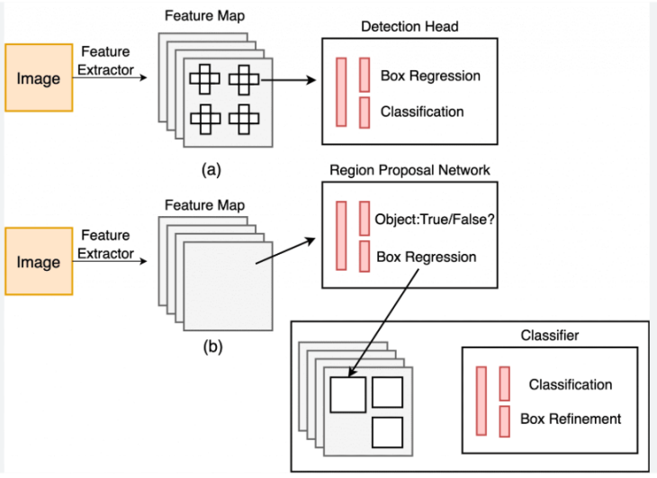

FF No 180

Group No. | TY-B-7
Activity | Review Schedule | Progress Review Report submitted | Signature of Guide
Review 1 | Mid Sem. Semester | Yes / No
Review 2 | End of Semester | Yes / No

Format of Progress Review Report:

Review No.: 1 Group No.: TY-B-7 Date: 23/09/2025

Progress Review Report

Overview
The project focuses on building an end-to-end real-time object detection pipeline using YOLO. The workflow includes dataset preparation, model training, evaluation, and deployment into a live application for detecting multiple objects in images and video streams.

Work Completed (≈75%)
- Problem Statement & Scope defined with clear objectives for dataset use, model training, and deployment.
- Data Collection & Preprocessing completed using standard datasets (COCO, Pascal VOC) and data augmentation.
- Annotation Formatting done with tools like LabelImg for YOLO-compatible training files.
- Model Development using YOLOv5/YOLOv8 implemented in PyTorch.
- Training Phase executed on GPU with hyperparameter tuning for accuracy and speed.
- Testing & Validation performed on held-out dataset.
- Performance Evaluation completed using precision, recall, F1-score, and mAP metrics.
- Intermediate Deployment achieved with inference on static images and pre-recorded video files.
- Integration with OpenCV for frame processing and bounding box visualization.
- Initial Flask Setup completed with / and /detect endpoints.
- Integration of Trained Model into Flask app to process uploaded images for detection results.

Pending Work (≈25%)
- Full Integration of Preprocessing Pipeline into the Flask endpoint for seamless inference.
- Enhancing /detect Route to support real-time predictions from live video streams (currently limited to images).
- Designing & Refining Front-End (index.html) for better user interaction.
- Further Optimization for latency reduction and achieving real-time FPS.
- Comprehensive System Testing across varied environments and conditions.
- Documentation & Packaging: polish final report, prepare usage guide, and finalize project submission.

Current Status
The project is approximately 75% complete. The YOLO model is trained, validated, and integrated into Flask for image-based detection. Deployment works, but real-time streaming is pending. Remaining work focuses on UI refinement, video integration, and final system testing.

Signature of Guide:

Review No.: 2 Group No.: TY-B-7 Date:

Progress Review Report

Signature of Guide:

